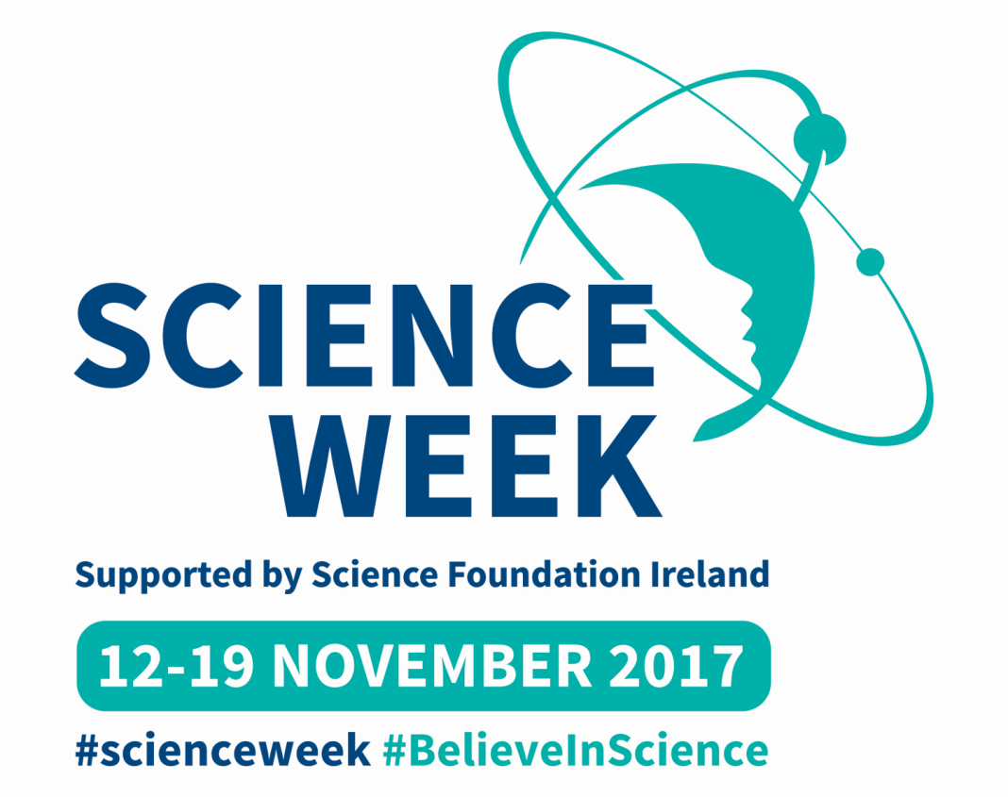

- On Thursday 23.11.2015 two Cloghroe NS Science Quiz Teams will participate in the Lifetime Lab Science Quiz in Devere Hall, UCC. Classes form 3rd-6th have been testing their science quiz skills over the last few weeks in preparation for this.

Why not try this quiz over dinner! http://www.sfi.ie/engagement/science-week/resources/2013-activity-sheets-Quiz.pdf

- Keep a close eye on www.cloghroens.com to see what scientific investigations are popular at different class levels.

See: www.corksciencfestival.ie

- On Wednesday November 15th from 18:00, Blackrock Castle Observatory hosts a workshop and stargazing. How did the universe get so big?

- On Friday 17th November at 19:30-20:30UCC will host a Chemistry Magic Show. The show is suitable for children of 10yrs +. Tickets are free and distributed on a first-come-first-served basis by sending an e-mail to Mr Brendan Fanning brendanrupertfanning@gmail.com

- On Sunday November 20th from 14.00-18.00, Neptune Stadium is the venue for Cork’s Community Festival of Science. There will be many science stands and activities to try out. Doors open from 14:00-18:00 and no booking is required. With free entry and lots of Science Week goodies to give away, a fun family day is guaranteed
- Here is a list of some science themed story books to enjoy with your children at home…perhaps a science book might make it to the Christmas List!
https://docs.wixstatic.com/ugd/3a66bc_6cc2bfd7070d4af1930613a373924293.pdf

