Cloghroe N.S.Policy on Exemption from Irish

Introduction:
This policy was drafted by staff and Board of Management (B0M) in response to ongoing changes in special educational provisions and the publication of Circular 0052/2019.

Rationale:
Circular 0052/2019 from the Department of Education and Science is the directing circular, under which a Board of Management decides who, may or may not, receive an exemption from Irish. This circular supersedes Circular 12/96 and the 2009 revision of that Circular both of which have been withdrawn. Existing exemptions from the study of Irish granted under Circular 12/96 and held by pupils will continue to apply until the end of their post-primary education.

Relationship to the school Ethos:
This policy is in keeping with the mission statement of the school, which strives to enhance the self-esteem of all through providing for the intellectual, physical, moral and cultural needs of all.

Aims and Objectives:
To allow for pupils of differing abilities, interests and circumstances
To enhance inclusivity within the school
To enable children of all abilities to access the curriculum in a learner friendly manner

Policy Content:
As per Circular 52/2019 (Section 2.2), exemption from the study of Irish may be allowed in the following exceptional circumstances only:
- pupils whose education up to 12 years of age (or up to and including the final year of their primary education) was received outside the State and where they did not have opportunity to engage in the study of Irish
Or
- pupils who were previously enrolled as recognised pupils in primary schools who are being re-enrolled after a period spent abroad, provided that at least three consecutive years have elapsed since the previous enrolment in the state and are at least 12 years of age on re-enrolment
Or
- pupils who:
- have at least reached second class
and
ii. present with significant learning difficulties that are persistent despite having had access to a differentiated approach to language and literacy learning in both Irish and English over time. Documentary evidence to this effect, held by the school, should include Student Support Plans detailing
• regular reviews of learning needs as part of an ongoing cycle of assessment
• target-setting
• evidence-informed intervention and review, including test scores (word reading, reading comprehension, spelling, other scores of language/literacy) at key points of review.
and
iii. at the time of the application for exemption present with a standardised score on a discrete test in either Word Reading, Reading Comprehension or Spelling at/below the 10th percentile.
Or
- children of foreigners who are diplomatic or consular representatives in Ireland.

Procedures for granting an exemption from the study of Irish:
Following a discussion with the school, a parent/guardian must make an application in writing to the principal of the school, if they wish to apply for a Certificate of Exemption from the study of Irish on behalf of a pupil.
The outcome of the application process will be conveyed by the school principal in writing to the parent(s)/guardian(s).
Where an exemption is granted, a Certificate of Exemption, signed and dated by the school principal will be issued.
Parents/guardians and pupils have the option not to exercise the exemption granted, without any loss of the right to exercise it at a future time.
It is the responsibility of the parent(s)/guardian(s) to ensure that a copy of the pupil’s Certificate of Exemption is made available to the receiving school.

Appeal Process:
Where the application for exemption from the study of Irish is refused, a parent/guardian can appeal the school’s decision to the Irish Exemptions Appeal Committee (IEAC). The deliberations of the IEAC will focus solely on the process the school engaged in reaching its decision. The IEAC will consider how the school followed the process as prescribed in Circular 0052/2019 and the accompanying Guidelines for Primary Schools.
An appeal must be lodged within 30 calendar days from the date the decision of the school not to grant an exemption was notified in writing to the parent(s)/guardian(s). The Irish Exemptions Appeal Form and Guidelines for Primary Schools can be accessed at
www.education.ie/en/Parents/Information/Irish-Exemption/

Roles and Responsibilities:
In-school Management, class teachers and the Board of Management will contribute to the implementation of school procedures.

Success Criteria:
Seamless integration of non-nationals and pupils with learning difficulties
Happy school learning environment
Positive teacher/parental feedback
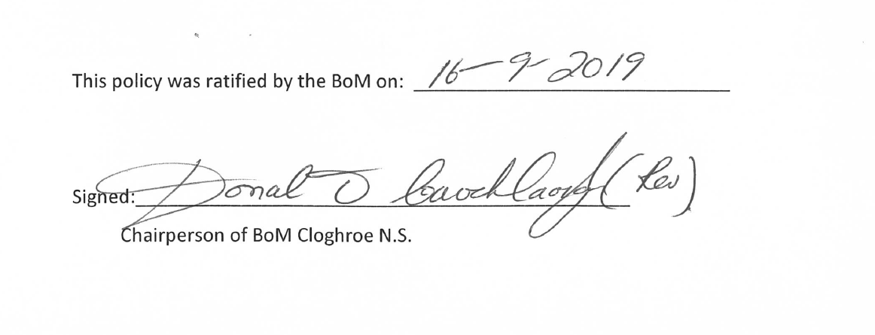
Review: This policy will be reviewed in line with any change of circular by the D.E.S.

