Cloghroe School ran a poster competition to raise awareness of the importance of staying safe online. 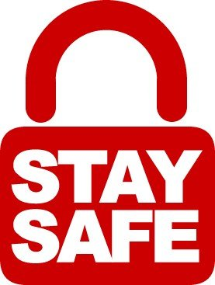
The four R’s of being safe online were represented and explored in our competition entries. Well done to all who entered!
Respect
Responsibility
Reasoning
Resilience

