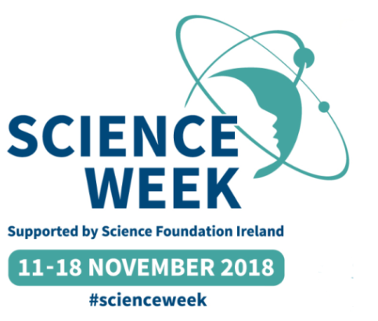

Cloghroe National School Science Week Activities

Wednesday 14 November 2018

- Two Cloghroe NS Science Quiz Teams will participate in the Lifetime Lab Science Quiz in Devere Hall, UCC. Pupils form 4th -6^{tth} classes have been honing their science quiz skills over the last few weeks in preparation for this. Best of luck to the six children who will represent our budding science whizzes on Wednesday!

Friday 16 November 2018

- 2nd class travel by bus to UCC to attend The Surprising Science Show hosted by Dr Matt Pritchard. The show will challenge the audience to discover the sneaky scientific secrets behind a host of illusions. This is not just an Awe & Wonder Show but one that encourages scientific enquiry and critical thinking skills.

- 3rd and 5th classes will receive hands on workshops facilitated by scientists from Designer Minds www.designerminds.ie. Each class will explore bacteria and take home their own individual agar plates!

Other Science Activities

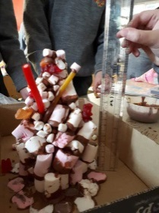
- 4th class are booked to attend the Lifetime Lab Primary School Science Workshops in March www.lifetimelab.ie

- Keep a close eye on www.cloghroens.com to see what scientific investigations are popular at different class levels in the month of November.

- We would love to hear from family members who work in the STEM sector and would be willing to come in to their child’s class as a Science Visitor. Thank you to those who have had the courage to do this in the past! Let us know of your willingness and availability to be a science visitor by note to your child’s class teacher or by phone through the secretary.

- Look out for the Science Apprentice books which are free to collect with the Irish Independent in SuperValu stores every Saturday in November. www.ucd.ie/scienceapprentice

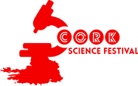
www.corksciencefestival.com
- Science Open Day at Western Gateway Building, UCC on Sunday 11.11.2018
- Festival of Science at Neptune Stadium on Sunday 18.11.2018

