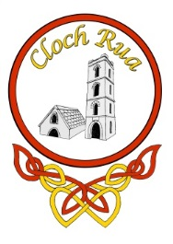
Cloghroe National School
Cloghroe, Co. Cork. Roll No. 07242M
Telephone/Fax: +353 21 4385547
E-mail: oifig@cloghroens.ie
Web site: www.cloghroens.com

Dear Potential Sponsor,

Please find attached a brochure outlining the opportunity to support our Cloghroe National School fundraiser, Cloghroe NS Goes To Broadway.

Cloghroe N.S., as a large school with a very wide catchment, in a beautiful rural location, plans to improve parking facilities, safety and access to CNS and will require large funds to do so. Our community, local and parental, has always been a terrific support and we are confident that this event will raise the huge funds required to fulfil our aim.

The fundraiser is a community effort and will see a spectacular show produced and presented by Kevin Rowe Events taking place on Saturday 15th February 2020 in the Clayton Hotel, Silversprings. There will be 700 audience members in attendance on the night, with many months of advertising and P.R. leading up to the event.

Two sponsorship packages are advertised within this brochure which offers incredible advertising opportunities for your business. We look forward to promoting your business in the months to come.

The committee member who has targeted your business will ensure that advertising details have been obtained from you. These include your sponsorship amount, accurate business details and an advertisement for the brochure.

Please contact the committee member named below for further info.

Name & Contact Number:

_______________________________________

cnsgoestobroadway@gmail.com

